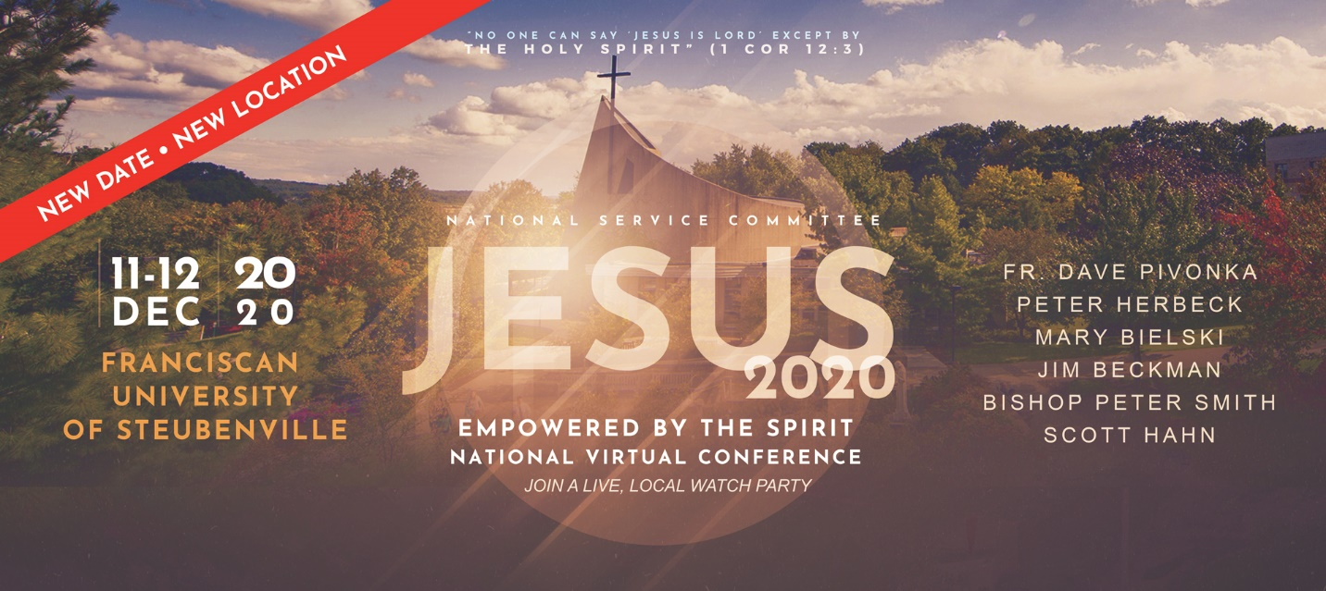
Come and participate in JESUS 2020 Empowered by the Spirit, a National Virtual Conference. Christ the King Church will host this live streamed virtual conference held at Franciscan University on Friday, December 11, 6 – 9 PM & Saturday, December 12, 8:30 – 4:30 PM in Fletcher Hall. Speakers are Fr. David Pivonka, Peter Herbeck, Mary Bielski, Jim Beckman, Bishop Peter Smith, and Scott Hahn. Please pre-register by contacting Charles Michie at 918-808-8358. Space is limited due to COVID-19 restrictions.

